**USEBEAN –**

UseBean:

The way we create and use java beans is through the JSP syntax :

*<jsp:useBean id=”” class=”” score=”” />*

* The ID Attribute is the name of the new Object.
* The class Attribute is the import off the JAVA class so path has to be defined there
* And the scope defines the scope you want your object to be set

As the line of code only creates an empty object (Bean) , its attributes have to be set.

And the other option is to set them one by one like this

*<jsp:setProperty name=”” property=”title” />*

* The name attribute has to match the Id of the bean

If the bean has a set method for an attribute called title it will have the name

Like : setTitle(String title) so when the jsp page will compile to a servlet page and lets say the name of the bean is book, it will be :

Book.setTitle(request.getAttribute(“title”));

*And title has to be the name of the input field in a form for example*

There is the option to set them all in one go like this:

*<* *jsp:setProperty name=”” property=”*” />*

Then it will go through the attributes in the request and see if there are matching set methods it will set them all in the same line.

All the forms in this project (excluding the file upload form) are using this syntax to create a new bean and store it to the session object. A good example would be the newProjectHandler (Picture 2) where a lot of information from a form is placed in a bean in just two lines :

  
(Picture 2 : *creating a new bean with the name newProject and storing it to the session*)

**Objectives**

The main objective is to create a Web application that is able to handle and document advertisement campaigns that Dell runs in different countries in the Nordic Area, and shrink the work load from Dell’s managers.

It is a platform that partners can go and start a project and request funding, presenting their idea and providing essential information like starting and finishing dates and a description. Then the region manager can read it and make comments if necessary and approve it or reject it.

There is communication tool in every project that keeps track of the conversation so the user can go back in time and read everything without having to search in emails witch is the way it works in the current moment.   
  
There is an upload function in each project so Proof of execution can be uploaded from the Partners side and be controlled by the supervisor of the project and if the proof that the project was executed as intended the project can be marked as finished and the fund is transferred to the Partner through e-banking or external services.

So the problems solved by using this web application are:

* One place for all users to communicate and act with.
* Book keeping to some extent.
* Easy overview of projects running.
* Partners are now responsible to start a project.
* Better and easier supervision of a vast workload for managers.
* Easier proof of execution handling (No more attached files in a mail :P ).

**Conclusion**

**Athinodoros Sgouromallis process**

This Project was a great way to force students to use all the things that has been taught throughout the semester.   
It was so stressful, but still so helpful, as the only thing we need is a push to learn new technologies.

1. Cons

We did not know enough to start the project. We knew a little about everything, but with no deep understanding of the process. We did not have enough confidence in ourselves.

Answers from teachers on the same question where not matching causing confusion and uncertainty to the group

The lack of a scrum master was a big problem at least in our group. A scrum master should be assigned by the teachers or a suggestion to rotate the role of a scrum master among the team members could be nice.

1. Pros

We did not know enough to start the project, BUT we had been shown the direction and that was good enough. This is a counter point for the first con. : When you figure out a solution on your own you fill ten times better than copying something someone else have shown you in class, and if you do figure/find a solution to problem by yourself it is most likely that you will never forget it.

We started reading articles on the net and learn about finding solutions and that is one of the most useful skills we could have when we go out there trying to find a job, and that skill is to be adaptive and open to new technologies.

When the group works good even if you fill you are stack you know can rely on your fellow group members.

**Suggestion for next go**

There should be an agreement between teachers so that everyone will be on the same page and if that is not possible there should be one teacher per subject like : database guidance, html/css, Junit testing, general syntax problems, UML etc. .   
This way less confusion will be caused to students.   
More often meetings with the group and the product owner so that we do not get of tracks and lose a lot of precious time.

**The Backlog**

The backlog was created really fast just before the project started and after a sort discussion in the group it was presented at the product owner before the Easter Holy Days.  
The backlog way ordered to fit the owner’s priorities and it took its final form.

1) as an admin I want an ER-diagram of the database ....

2)as a re-seller I want to be able to start a new project so I can be approved

3)as a re-seller I want to be able to edit my project so I can get approval if I got declined

4)as an admin I want to be able to see a project so I can approve it

5)as an admin I want to sort the projects so I can have a better view

6)as an admin I want to see approved projects so I can supervise them

7) as an admin I want to see money left unspent so I can allocate them elsewhere

8)as an admin I want to log-in so I can access the dashboard

9)as an admin I want to see finished projects so I can see money spent

10)as an admin I want to filter projects per steps so I can see the progress

11)as an admin I want to be able to delete projects so I can clear junk or false projects

12)as an admin I want to able to pick the currency so I can compare more clearly

13)as an admin I want to have a report with statistics per country so I can see the progress

14)as a re-seller I want to able to add media files so I can prove my work

15)as an admin I want to set the max budget per quota so I can have a clear view

16)as a partner I want to access proof of execution so I can see that our agreement is fulfilled

17)as an admin I want to be able to back-up the database so I can recover in case of data loss

The green projects are the ones that are implemented and working at the current moment.  
The yellow ones have full back end support but there are not implemented in the front-end.  
The red ones are backlog items that we dropped either because the product owner/teachers said it is not needed or did not comply to the businesses architecture.

As the first days were passing we were adding some new cases to the side bar like :

18)as an admin I want to create new users so they can access the system

19) If a project is finished it should be possible to have a printable document (PDF)

20)As a user I want to receive a mail if a change was made to a project I am a part of.

But not all of them made it to the actual backlog as they were forgotten or there was not enough time to implement them in the project.

(((The user stories could have been made better and by that I mean that the User stories could have been more simple and broken down to simpler more understandable stories for an actual product owner.)))

Not all user stories were fulfilled in the project due to group issues.

**HTML/CSS/JSP**  
  
Using JSP for this project:

Java Server Pages (JSP) in an amazing tool that can help you develop webpages in plain java. The upside is that we already know java and it was a good practice and a solid step forward in implementing Java in different environments. At start the java/HTML code seemed abstract with all the new annotations (for example : <% %> ) but once you learn/realize that this file will be converted into a servlet reverting the code and leaving java code as-is and placing HTML code with an OutputStream, it makes total sense.  
  
During the project we figured out more ways to solve a problem in a JSP and through many resources on the internet we learned more clever/efficient ways to improve our code.  
  
As a solid example of a case like that the way we represent the Dashboard after the log-in screen. In the beginning we had a discussion on how we could handle all the different pages that will obviously have the same menu item, header and footer actually the only thing that was supposed to change was the main area of the Dashboard JSP. So we agreed to use include functions in JSP.

**The include statement**   
  
A small note on how this function works and what its syntax looks like.  
Syntax:   
<jsp:include page=”” /> And inside the page attribute goes the path(only if the JSP in not in the default folder ) and the name of the JSP we want to include in a “Parent” JSP.

The Dashboard(Picture 1) is a perfect example of a good use of that command were the code is minimized to just few lines and it gives the opportunity to split the complexity to smaller files :

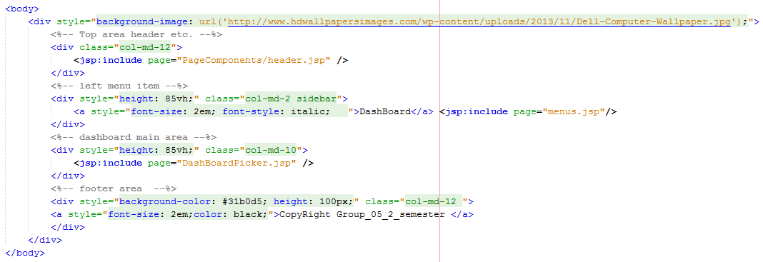(Picture 1: *Body element of the Dashboard*)

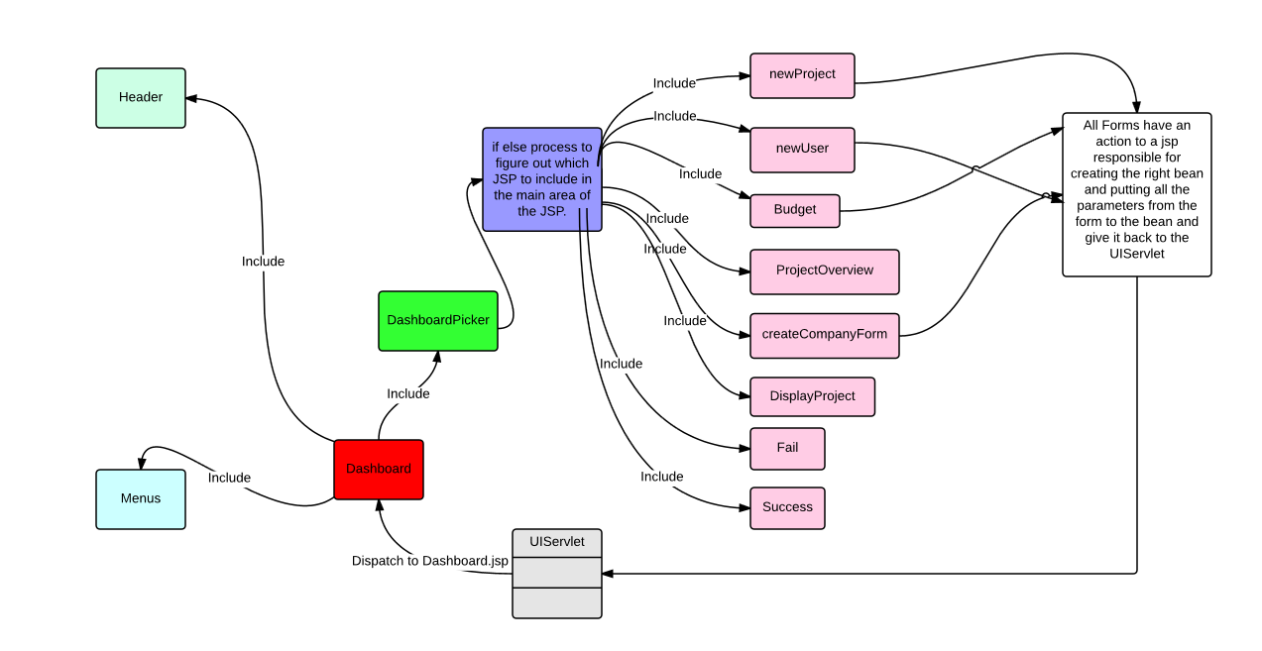Here is a graphical representation of how our Dashboard looks and works like (Picture 3) and what the basic idea behind our design is.

(Picture 3: the logic behind the dashboard.

The UIServlet dispatches to the Dashboard with the only exception when the log-in process fails.

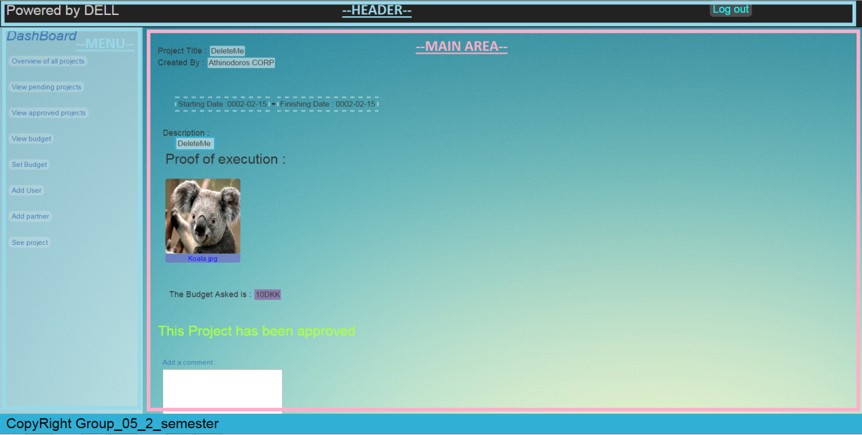

Areas that   
include jsps

(Picture 4: The dashboard and its componets )

**The Dashboard**

The Dashboard (RED box) includes 3 different JSP files, the menus.jsp , Header.jsp and DashboardPicker.jsp. The first two (CYAN boxes) are concrete components of the Dashboard Page so they are always the same and they are always included.  
The third jsp that is included in the DashboardPicker (GREEN box) and is of great importance because this jsp looks into the request and gets an attribute called mainArea and through multiple if else statements it decides which of the main area jsps (PINK boxes) to display/ include. Then if the jsp displayed is a form or contains a submit button it will jump to a bean handler jsp and from there back to the servlet.

So every time a JSP is included in another page the compiler disregards the child’s page title and basically the parent takes only the code and tags that exist inside the <body> tag(If there are commands in the <head> like imports and links to Cascade style sheet they will be executed).

**Using HTML and CSS:**

The usage of HTML(Hyper Text Markup Language) was a pleasant think to use it Is easy, and you can create a really good webpage with it. And by adding css it becomes a piece of art and this actually an under underappreciated field. With the use of JSP you can generate HTML in a page like we do in Project Overview. The opportunities unfolding in front of us are so great and kind of endless.

We made use of all three ways to add CSS to a page, and we made use of Bootstraps as well in a small extend.

The idea of having a lot of CSS files in one project was up for discussions with two opinions one side said one CSS document is more than enough for the whole project and the other side said it is ok to have three different CSS for different cases. We do not use most of the Bootstraps CSS files, but some of the already existing once where modified to match our needs.

**DESIGN AND ARCHITECTURE**

This part of the report will be presented in two layers, the view layer and the source layer.  
  
The view layer takes care of what should be presented on the screen and what are the patterns that we use in the project.

The source layer is split in three layers the presentation layer that speaks both to the view and the source, the domain layer and the Data Source layer.

**The file handler**

After a lot of attempts to create the right table to save the proof of execution and hold all the right information inside, the idea was dropped because of the luck of time. The idea of writing a BLOB item in the database seemed great in the beginning and ferly easy. After reading and trying out most of the ideas on the internet and books, it seemed that an input stream could not be inserted in the binary data column on our POE table.

But we did not give up the idea no matter the stress to finish the project so we implemented the original idea. That idea that we implemented last minute is simple yet intelligent one.  
It doesn’t store the files on the Database but on host/localhost. Every time a Partner tries to upload a file a new directory is created with its company’s company name if there wasn’t one there. Next a new folder for each project named after the projects id and files are pleased there. This file system prevents file scrambling and file overlapping although a project is not able to contain two files of the same name. So the Database is not needed to access these files or to see how many files there are for a single project.   
The way our project sees the files:

* When a project is selected to open information about it are stored in the session and the request objects.
* Then a String is built part by part.
* First it get the actual path using the servletContext like this : request.getServletContext().getRealPath("/").
* Then the name of the company is added.
* And lastly the id of the project
* Then a new file object is been created with that path created
* Then an array of Files that uses the file to read the directory and return a list on files like this:

File[] files = file.listFiles();

* Then this arrays of files is put into the session object and gets passed down to the jsp.
* The jsp uses this list to get the title and the path display the title and the actual image if possible.

**The Project view**

The project view is one the page with the most importance of all because of its functionality which is:

* View projects general information.
* Approve Project
* Upload files (if the user is a partner)
* Change the description (if the user is a partner)*1
* Communication tool between the partner and the manager.
* POE view

*1**:** Every time the description is changed a comment made using the user information of the person changing the description to avoid misunderstanding like the admin is not aware of the change and approves the project unwillingly. That comment contains the old commend and new comment for comparison and documentation reasons.

It iterates through a file array and displays pictures optimized to fit one next to the other.

Also this particular page acts differently according to the user that is accessing it and its status, some example are given:

* The file uploading is only possible only while the project is preapproved or approved.
* The admin cannot change the Description only the Partner can.
* The Partner can change the description only before the project is approved.
* Only the admin can approve a project
* Once approved it not possible to disapprove even for the admin

A small feature is added in the comment area that helps the reader. The idea came from dells documents that highlight names differently in a conversation. When an admin leaves a comment his name in the comment area is marked with green, and when a partner does, his name is marked with blue.

**Patterns (small)**

We used all the patterns to add css :

* Inline
  + <div style=”css,css,css”></div>
* In flie
  + <style> h1{ css,css,css } </style>
* In external css sheet
  + *.css file

**Error handling in the UI**The error handling that takes place in our project is more like error prevention. We try to guide the user by restriction to act as we expect him to act living him/her with less options to input false data. For example here (picture 5):

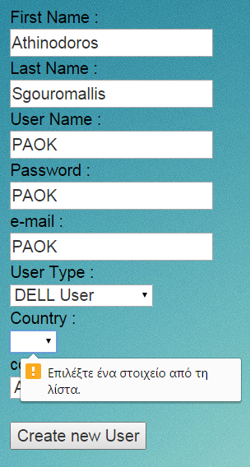All the fields that have to be filled are marked   
as mandatory in the code.

Fields That take only specific values are   
dropdown lists.

Although no methods where made to check  
 them further for example if an password is   
more than 8 characters |with mixed symbols,  
 capital and lower case letters

(picture 5: create user Form)